**Nuclear Magnetic Resonance (NMR)**

**References**

C. Kittel, *Introduction to Solid State Physics* (4th Ed, Ch17)

H. Mark and N. Olsen, *Experiments in Modern Physics*

Daryl W. Preston and Eric. R. Dietz, *The Art of Experimental Physics, Wiley,*, N.Y. 1991

**Purpose**

This lab is designed to study nuclear magnetic resonance in condensed matter, the magnetic moment of the proton, and the effects of the molecular environment.

**Equipment**

Variable high field magnet, sample holder with RF and Helmholtz coils, tunable CW marginal RF oscillator, audio frequency oscillator, frequency counter, Lock-In amplifier, variable attenuator, oscilloscope and computer with ADC and DAC interfaces.

**Field Dependence of the Resonant Absorption Frequency**

1.Set up the apparatus as shown below for displaying the signal on an oscilloscope.

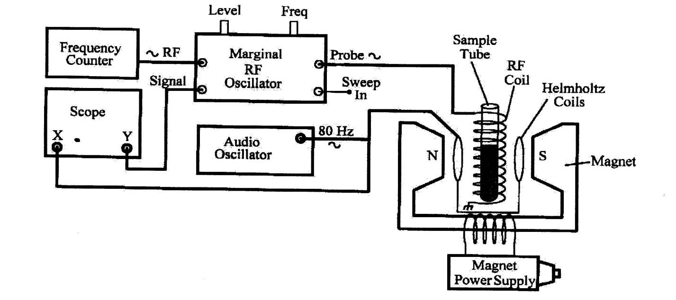

2. Put in the distilled water sample. Set the audio oscillator to an 80 Hz triangle wave and at maximum amplitude. This sweeps the total magnetic field linearly through the resonance at 80 Hz. Adjust the RF level to obtain a suitable noise pattern on the scope with an RF frequency near 14.290MHz. Slowly vary the magnet power supply current until you see the nuclear resonance on the scope. The 10 turn current dial will be at about 5.2. Why are there two peaks on the scope?

3. Make measurements of the resonance frequency with field current dial reading. You can use a Hall probe to calibrate the current dial in gauss.

4. Measure the linewidth of the absorption resonance in gauss. Measure the current in the Helmholtz coils by using the 1 ohm resistor in series with the coils. With this current, the dimensions and number of turns of the coils, calculate the magnetic field produced by the coils. Then from the scope display estimate the linewidth.

5. How is the RF frequency varied by the RF oscillator and how does it detect the absorption signal? Why is the RF coil perpendicular to the large magnetic field?

**Lock-In Enhanced Study of the Absorption Profiles**

1. Set up the apparatus as shown using the Lock-In amplifier and computer to take data.

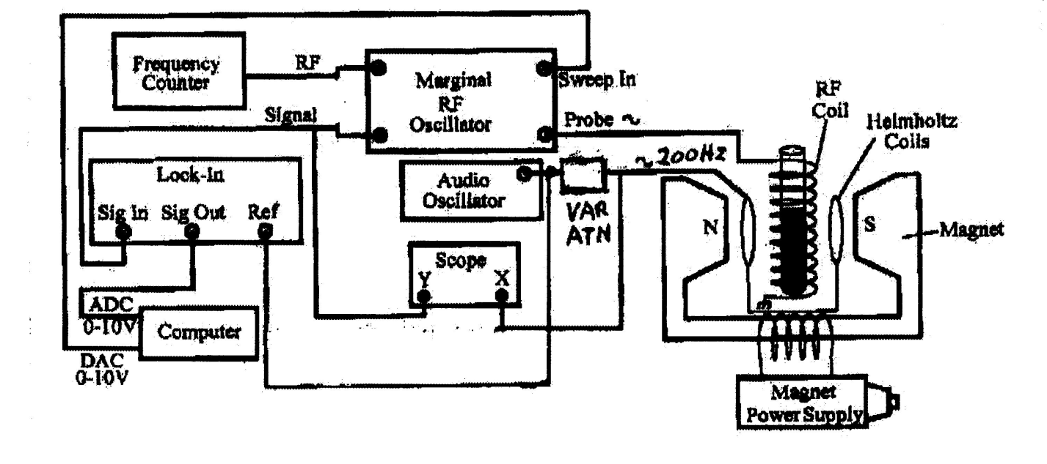

2. Set the audio oscillator to a 200Hz sine wave and reduce the amplitude to about 2Vpp so that the magnetic field sweep is less than the resonance linewidth. The audio oscillator dithers or modulates the Helmoltz field and produces a resonance signal in phase with the audio oscillator. The modulation amplitude can be set by the 10 turn variable attenuator. The Lock-In amplifier detects only signals that are in phase with the reference i.e. the audio modulation. The output of the Lock-In amplifier is the derivative of the absorption profile as seen on the scope in the previous experiment. Why?

3. Set the variable attenuator fully clockwise to give maximum modulation. Find the resonance again on the scope and measure the modulation amplitude. Now change the large magnetic field a little until the resonance is just gone. Knowing that the RF frequency will sweep up in frequency with the computer, does the field need to be decreased or increased? Use the NMRSCAN program on the computer and record a scan of the resonance. Determine a way to measure the absorption linewidth from the scan. Keep reducing the modulation level and take data for each. Make a plot of linewidth as a function of modulation amplitude. Find the natural linewidth from the plot.

4. Try different samples and determine the resonance frequencies and linewidths. Are the frequencies noticeably different from water? Give plausible explanations for your frequency measurements to be different or the same.

5. Investigate the time constant T2 by using a saturated LiF water sample. Set the audio generator frequency to 80Hz and maximum amplitude. Use the scope and look for wiggles as the magnetic field passes through resonance. Vary the audio frequency to see the most defined wiggles. Save the resonance waveform and use it to make a plot of wiggle amplitude with time. Determine T2 and explain what it measures.